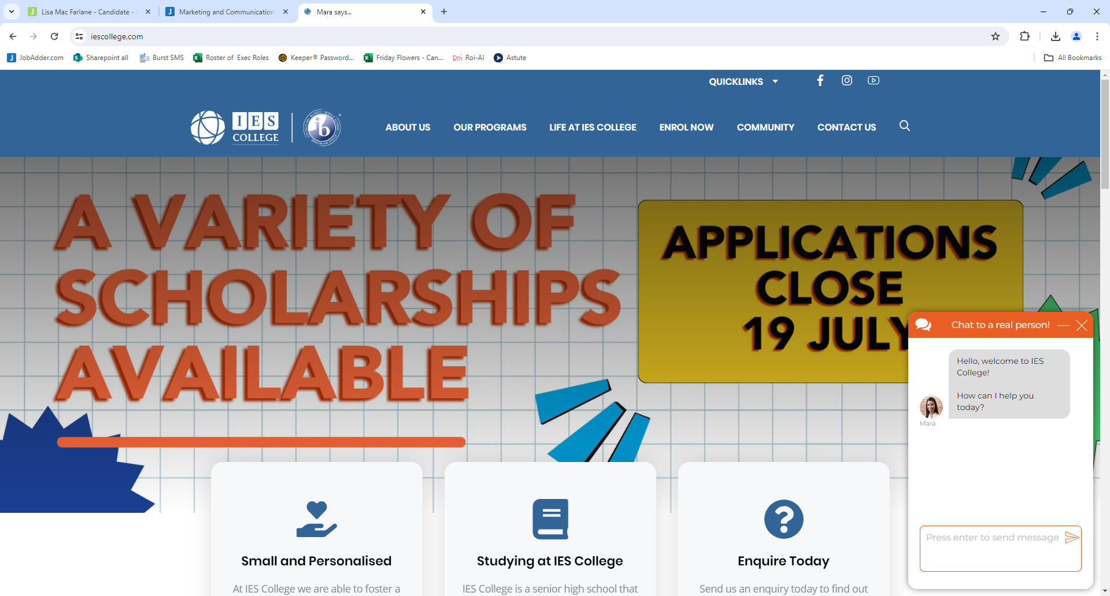
Position Description: Marketing and Communications / Enrolments Manager
Mission:
We are committed to empowering students so they, in turn, serve to empower others in their local and global communities.
Vision:
Our vision is to inspire students to be passionate and empowered learners, confidently developing their individual gifts to serve in a global world.

The Marketing and Communications/ Enrolments Manager has overall responsibility for the development of marketing, communications, public relations, community engagement and building the College brand and visibility within the community.
They will be recognised within the College community as an exemplary communicator with excellent writing and verbal communication skills. They will support and model the College’s values and ethos when dealing with all stakeholders acting as an outstanding ambassador for the College, promoting its policies and exemplify its standards.
This position will also take responsibility for all enrolments at the college and as such will always maintain confidentiality on all school matters. Due to the nature of the role, on occasion, some duties will need to be performed at times other than during the day, including after-hours in the evenings and on weekends with time in lieu available.

Key Responsibilities:
The Marketing and Communications/ Enrolments Manager is responsible for the following roles and duties:
Marketing and Public Relations
- With the support of the College Leadership Team, develop and implement a progressive strategic marketing plan to build and sustain student enrolments
- Producing and maintaining a yearly marketing, communications, event, advertising and College promotional annual plan and calendar in line with the College marketing strategy
- Producing and presenting marketing reports as required
- Monitoring trends and conducting regular, relevant market research, using this knowledge to develop, implement and measure the success of the strategic marketing plan and marketing annual action plan
- Developing and managing the annual marketing and communications budget
- Maintaining a comprehensive resources bank/marketing toolbox including advertising copy, style guide, photographs, audio-visual and publication for print, and social media platforms
- Promoting the profile of IES College to College families and externally to the wider community through public relations, the creation of awareness and social media followship
- Chair the marketing team meetings
Digital Marketing
- Maintaining the College’s website and social media platforms on a continuous basis
- Oversee the design and ongoing operation and maintenance of a constantly evolving and improving College website
- Monitoring and managing the College’s reputation by paying particular attention to all media and social media coverage, including comments and reviews
- Creation of regular, high-quality and engaging content
- Responsible for taking photography and film of college events and activities
- Edit and produce short videos
- Creation and oversight of the digital content calendar
College Newsletter
- Coordinate targeted written and development of visual content for the fortnightly newsletter (including photography and video)
- Liaise with stakeholders and subject matter experts to develop content for specific campaigns, media and advertising
- Ensuring all media opportunities are captured and promoted in a number of areas including social media, newsletters, website etc in a consistent manner
Event Coordination
- In liaison with the College CEO, provide administration and support for events, for example school tours, community celebrations, open days, transition events etc including event planning, ticketing, compliance paperwork, catering and publicity
Stakeholder Management
- Managing the College’s external marketing suppliers/consultants including but not limited to: Consultants, Designers, Printers, Manufacturers etc
- Fostering and building relationships with staff to ensure a consistent and integrated marketing approach across the College
- Providing marketing support to staff responsible for coordinating events
- Any other duties as directed by the College Principal / Leadership Team
Enrolments
- Attend to general enrolment enquiries from students and staff and general public
- Manage enrolment process
- Report and analyse enrolment data.

Key Selection Criteria and Qualifications:
Essential Qualifications
- Tertiary qualification in Marketing, Communications, Public Relations, or a related field, or equivalent practical experience
- At least 3 years of experience in marketing and communications, preferably within an educational setting
Strategic and Creative Skills
- Proven track record of developing and implementing successful marketing and communication strategies
- Strong skills in content creation and copywriting
Collaboration and Stakeholder Management
- Ability to collaborate effectively with team members and internal stakeholders
- Experience in managing multiple stakeholder relationships and expectations
Technical Proficiency
- High level of proficiency with Microsoft Office Suite and comfortable working with both Mac and PC environments
- Skilled in using Adobe Creative Suite or similar graphic design software
- Knowledge of SEO, keyword research, and Google Analytics
Multimedia and Social Media Expertise
- Experience in photography and video production, utilizing multimedia for storytelling across diverse audiences
- Proficient with various social media platforms and associated digital marketing techniques
Communication and Interpersonal Skills
- Exceptional communication skills, coupled with a creative approach
- Excellent interpersonal skills for building relationships with students, families, and staff
Organizational Abilities
- Strong time management and organizational skills
- Ability to handle confidential information with the utmost discretion
Independence and Customer Service
- Capable of working independently in dynamic environments, managing priorities and deadlines effectively
- Outstanding customer service skills and a commitment to a growth mindset
Attitude and Teamwork
- A proactive approach to continuous improvement and efficiency
- A positive and resourceful team player with a collaborative spirit
Compliance
- A demonstrated commitment to the safety, wellbeing, and inclusion of all children
- Current Working with Children Check

